**Application Building**

Execute And Test Your Model

|  |  |
| --- | --- |
| Date | 31 October 2022 |
| Team ID | PNT2022TMID53522 |
| Project Name | Smart Lender - Applicant Credibility Prediction for Loan Approval |

1. Landing Page and User Input Form

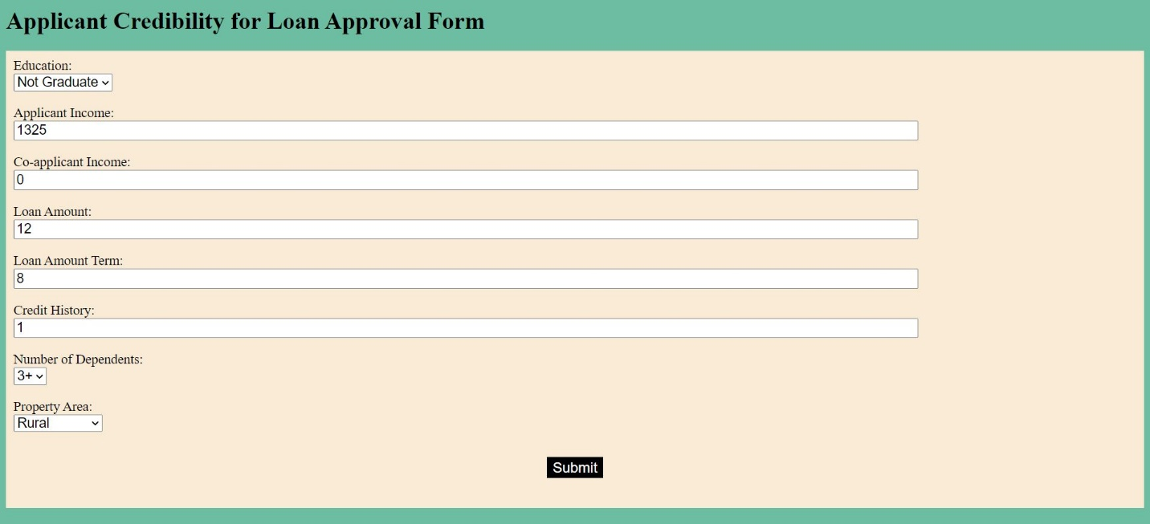

1. Display Page for Predicted Output

